METR3100

Control System Implementation

PART B: Actuator selection and performance evaluation for an autonomous electric vehicle.

|  |  |
| --- | --- |
| Sean Plunkett | 43570582 |
| Mahendra Pokhrel | 43180927 |
| Samuel Williams | 43219667 |

# Executive Summary

Contents

Executive Summary 0

1 Introduction & Scope 1

2 Task 1 2

3 Task 2 3

4 Task 3 4

4.1 Dynamic Model for Energy and Charge 4

4.2 Battery Selection and Parameters 5

4.3 Connection Methods 6

4.4 Urban/City Drive Cycle 6

4.5 Energy Consumption, Battery Configuration 6

4.6 Hinterland Cycle Results 7

4.7 Drive Cycle Results 7

5 Task 4 8

6 Conclusions 9

7 Bibliography 10

# Introduction & Scope

# Task 1

# Task 2

# Task 3

Task 3 evaluates the power, energy, and battery requirements of the actuation system for the electric vehicle.

## Dynamic Model for Energy and Charge

For the solution to meet requirements it must be capable of completing a long-distance travel cycle (as shown in Task 2) and an urban drive cycle without running out of power. To calculate the charge and battery capacity requirements of the system a dynamic model for the charge of the system was conceived.

Based on the force output of the vehicle of the system and the displacement generated we can say that the instantaneous work completed by the vehicle is equal to Equation 1.

$$Work=Force*Displacement [J]$$

Equation : Work

Additionally, we may say that the power over any sampling interval is equal to Equation 2.

$$Power=\frac{work}{time}=Voltage*Current [W]$$

Equation : Power

The charge stored within a battery is given by Equation 3.

$$Charge=Current*Time [C]$$

Equation : Charge

From this we find charge as given in Equation 4.

$$Charge=\frac{Power}{Voltage}*Time=\frac{Work}{Voltage} [C]$$

Equation : Finding Charge

Therefore, for calculating the charge requirements of the batteries for the system we can find the work from the values calculated in Task 2 and divide them by the voltage requirements of the system. Additionally, in instances where the specifications of batteries is given in power (e.g. kWH) the power found can be used to select batteries.

In the simulation this is shall be modelled by calculating the work done by the system in a sample, dividing by the time increment of the sample, before subtracting power consumption from the total power (note: that regenerative braking, as a percentage, has been included in this model, but is 0% for all testing in Task 3.). This value can then be divided by the voltage requirements of the system to calculate charge requirements. This is implement as seen below in Snippet 1: Charge Requirements.

Snippet : Charge Requirements

|  |
| --- |
| % Find work in joules  W = ds*F_trac;  % Find power in watts  P = W/dt;  if (P > 0) % If motor uses power  bat_o = P; % Power used is expended  bat_i = 0; % No incoming power  else % If motor doesn’t use power  bat_o = 0; % No outgoing power  % regenerative braking adds power,  % but in task 3 REGEN_BRAKING_EFFICIENCY = 0%  bat_i = (-P)*REGEN_BRAKING_EFFICIENCY;  end  % Battery power is updated  % bat_total initialised as stored power  bat_total = bat_total - bat_o + bat_i;  % Battery charge is updated  charge_total = bat_total/voltage_req; |

## Battery Selection and Parameters

While several batteries where evaluated the Panasonic NCR18650B was selected as the batteries to be used in the electric vehicle. It was selected in particular for 3 reasons:

1. It satisfied the designed requirements;
2. Datasheets and documentation existed to verify the results; and,
3. Existing electric vehicles, so empirically tested results (analogous to our conditions) were obtainable.

The key values for the from its datasheet are summarised in Table 1: NCR18650B Specifications.

Table : NCR18650B Specifications

|  |  |
| --- | --- |
| Minimum capacity | 3,250 mAh |
| Maximum Mass | 47.5 g |
| Gravimetric Energy Density | 243 Wh/kg |
| Nominal Voltage | 3.6V |

Fortunately, the effective values for a system implementing the NCR18650B (the Tesla Model S) are known, as summarised in Table 2: Empirical NCR18650B Specifications.

Table : Empirical NCR18650B Specifications

|  |  |
| --- | --- |
| Number of Batteries | 7104 |
| Rated Energy | 85 kWh |
| Mass Total | 540 kg |
| (calculated Gravimetric Energy Density) | (157.4 Wh/kg) |

From this when can find the worst-case scenario for actual battery requirements. Additionally, from the input voltage given by the datasheet found in task 2 it is possible to evaluate the required voltage for the motor. This results in the values for calculation shown in Table 3: Values for Calculation.

Table : Values for Calculation

|  |  |
| --- | --- |
| Rated Energy Per Battery | 43074 J (11.965 Wh) |
| Mass Per Battery | 76 g |
| Input Voltage | 108V |

## Connection Methods

Values for the efficiency of the NCR18650B could not be found. However, as noted these batteries are used in the construction of the Tesla Model S; compared to the Nissan Leaf the Tesla Tesla Model S has @@@% greater capacity with @@@% greater range, implying that the Tesla Model S is more efficient. Therefore we may assume that the battery efficiency of the Nissan Leaf is the lower bound or the worst case efficiency for the NCR18650B. Fortunately @@@ has done extensive testing of the efficiency of the batteries used in the Nissan Leaf revealing the efficiencies noted in Table 4: Nissan Leaf Efficiencies.

Table : Nissan Leaf Efficiencies

|  |  |  |  |  |
| --- | --- | --- | --- | --- |
|  |  |  |  |  |
|  |  |  |  |  |
|  |  |  |  |  |
|  |  |  |  |  |
|  |  |  |  |  |
|  |  |  |  |  |

## Urban/City Drive Cycle

To best test for a city drive cycle research was conducted into drive cycles. The New European Driving Cycle (NEDC) is a driving cycle used to test vehicles in urban and extra-urban driving conditions. The drive cycle includes specified speeds and accelerations that must be maintained for a set amount of time. The full drive cycle has a duration of approximately 20 minutes (1180 seconds), and features numerous stops, start, rapid accelerations, and decelerations. The velocity profile for the cycle can be found in Figure 1: NEDC.

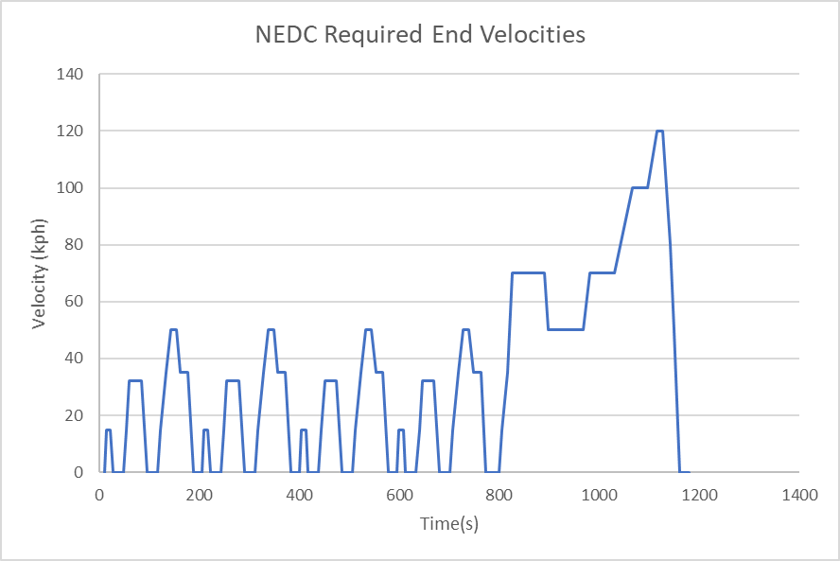

Figure : NEDC

The NEDC was chosen as it simulates the conditions required from a light vehicle under urban conditions, precisely the requirements for task 3. However, it is noted that the NEDC is brief, so testing shall be conducted for four back-to-back runs of the NEDC, simulating about an hour and a half (approximately 80 minutes) of city driving, approximate to the worst of across-the-city-during-peak-hour traffic.

## Energy Consumption, Battery Configuration

Accurately finding the battery requirements of the journey is an iterative process. Changes in the quantity of batteries changes the mass of the batteries, which changes the power requirements and the quantity of batteries.

To find suitable battery configurations simulations were conducted with no batteries, the charge deficit was then used to inform approximate values for batteries required. This process was repeated until the battery requirements for both drive cycles were met. Then a safety factor of 1.5 was added.

## Hinterland Cycle Results

## Drive Cycle Results

# Task 4

# Conclusions

# Bibliography

**There are no sources in the current document.**